AWS IoT Configure

1. Create certificate for device
2. AWS IoT button configure
3. Please login via <https://console.aws.amazon.com/iot/home?region=us-east-1#/thinghub>
4. From left panel, click **Manage** > **Things** > **Register a thing**

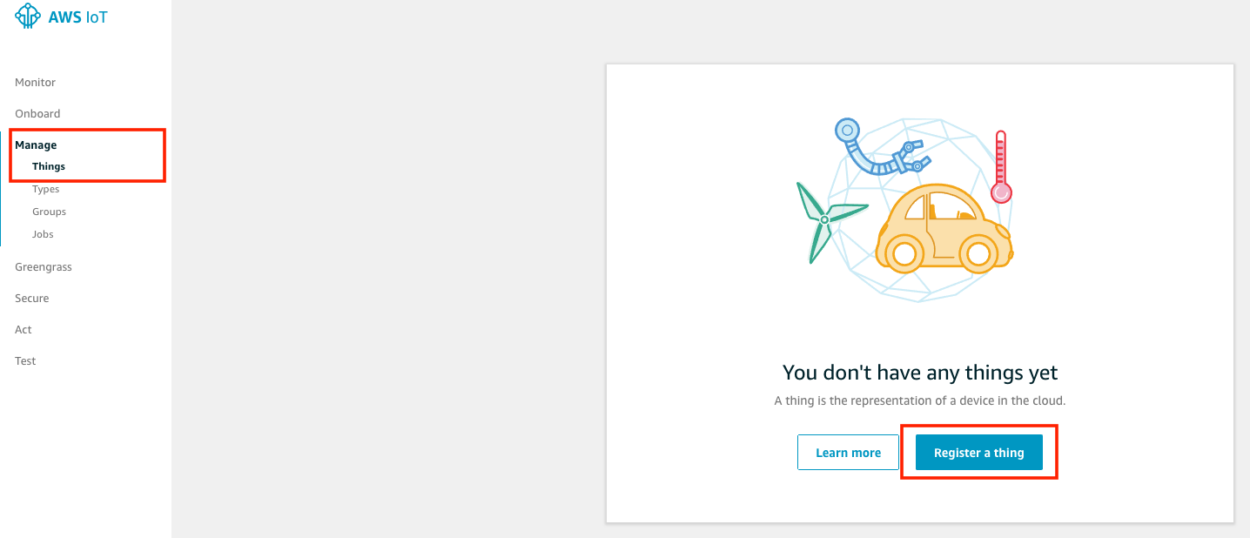

1. Click **Create a single thing**

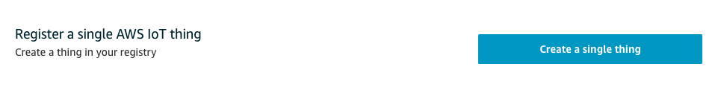

1. Type a name of device and click **Next** at the bottom of the page

